PHYS 454, Homework 2

Orbits and more

Spring 2024

1. **Prove Kepler's second law (numerically)**
   1. Use JPL Horizons Web app ( <https://ssd.jpl.nasa.gov/horizons/app.html#/>) to retrieve some position data about an object orbiting the sun. Try to show Kepler's 2nd law by numerically estimating the area swept out by the orbit during a short time duration and comparing that area to an equal time duration at another location along the orbit.

You can pick your own object but it needs to have an eccentricity value greater than 0.1 (and less than 1.0) (Many comets are in this range)

You'll want to pick the right output values in your JPL Horizons query. The Observer range & range-rate and True Anomaly Angle are your best bets here. (Though you could do it with several others as well.) Read the documentation about the output table entries: [Definition of Observer Table Quantities](https://ssd.jpl.nasa.gov/horizons/manual.html#obsquan).

Explain your process and the geometry you did.

* 1. Make a plot showing the orbit of the object you chose as well as the orbit of the Earth around the sun for a comparison/reference. (The techniques used in problem 3 will be helpful for this)

1. **(Not) to Scale**

Find an image online that shows an astronomical illustration that is made out of scale. Comment on what is 'wrong' with it.

1. **IM1 Mission**
   1. Prepare a plot that shows the trajectory of the recent Intuitive Machines to land on the moon, from a bird's eye view of looking down on the Earth Moon system.

Here is a version that you can use as guidance to see what the trajectory looks like. But make a nice plot with axes, etc.

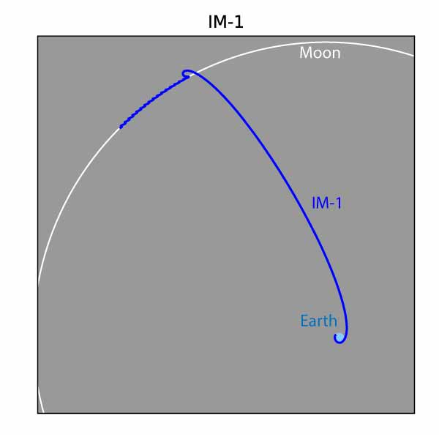

* 1. Prepare at least 2 other plots showing something interesting about the trajectory. Perhaps showing a zoom in of a region. Or plotting a view from a different direction (i.e. lik X and Z instead of X and Y), or including the velocity information. Your choice. But do something interesting. Comment on it.

For all

* Include your sources and a table of the raw data you used. (This ideally would be a link to your data file online somewhere, like a github repository or google drive link. Make sure sharing is set properly so that with a single click, it can be viewed.)
* Make sure all plots are formatted nicely and have labeled axes.

Due Date: Wednesday March 6, start of class. (via blackboard)

Prepare your work in a typed (no handwritten math or drawn diagrams), document (pdf) with plots and any citations for any references you used, and links to any extensive code you wrote that was used.